Module -6

Q-1) What are events in Google analytics?
Answer-1
Events in Google Analytics are specific user interactions or actions that take place on your website or app which you want to track separately from normal page views.
A page view only tells you which pages people visited, but it does not tell you what actions they performed on that page.
That is why events exist — to help you understand how users behave.

Why events are important?
Events help you track meaningful interactions, such as:
- Did the user click a button?
- Did the user watch a video?
- Did the user download a file?
- Did the user fill a form?
- Did the user spend time on an important page?
Events allow businesses to measure engagement, interest, and conversion behaviour.

Key components of an event (GA4 version)
In GA4, events have automatic parameters and custom parameters.
Each event can contain:
- Event name → What action happened (e.g., button_click)
- Parameters → Extra details about the action (e.g., button name, page URL)
Example:
If a user clicks “Buy Now”, the event may record:
- Event name: button_click
- Parameters:
  - button_name: "Buy Now"
  - page_location: "/product-page"

Types of Events in GA4
1. Automatically Collected Events
These happen without any setup.
Examples:
- page_view
- session_start
- first_visit
2. Enhanced Measurement Events
Can be turned ON/OFF in GA.
Examples:
- scroll
- outbound_click
- file_download
- site_search
3. Recommended Events
Events that Google suggests based on industry.
Examples:
- purchase
- add_to_cart
- login
- sign_up
4. Custom Events
Events created manually using Google Tag Manager.
Examples:
- video_started
- contact_form_submit
- cta_button_click

Q-2) Connect your created website and blog to search console, analytics, and google tag manager and add your faculty as a user with required permission in it.
Answer- 2
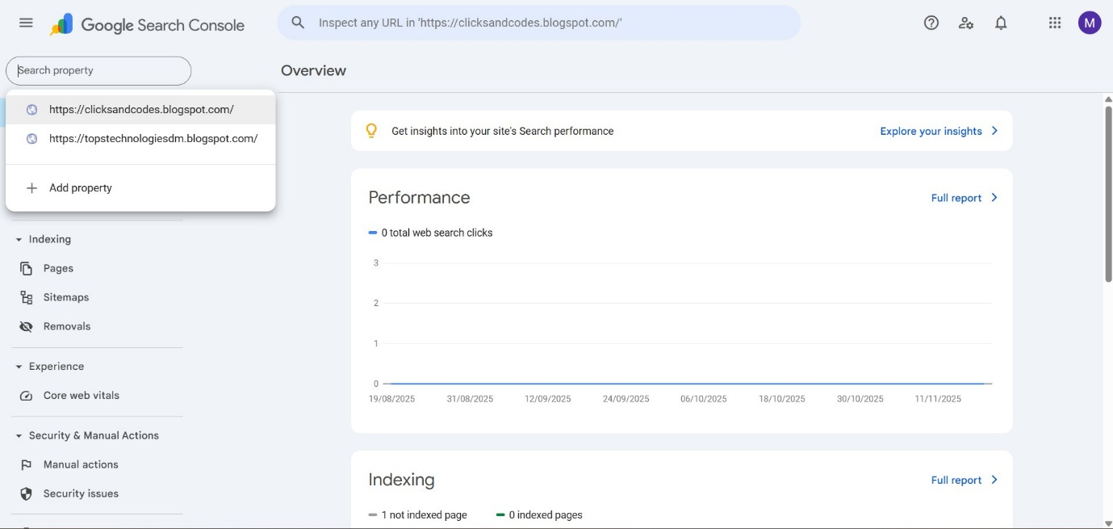
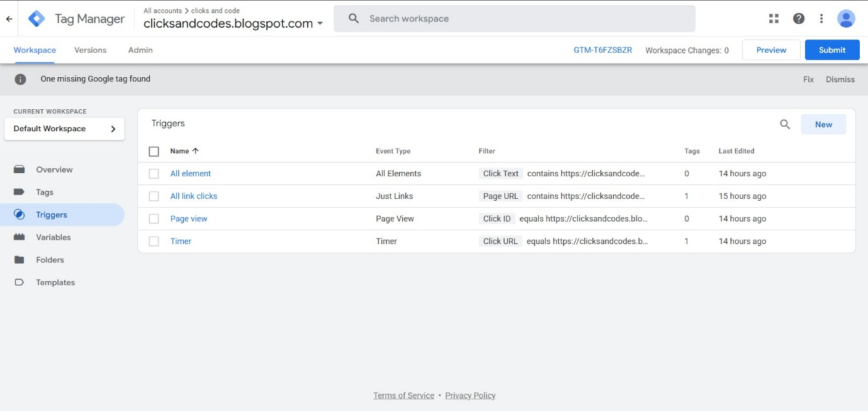
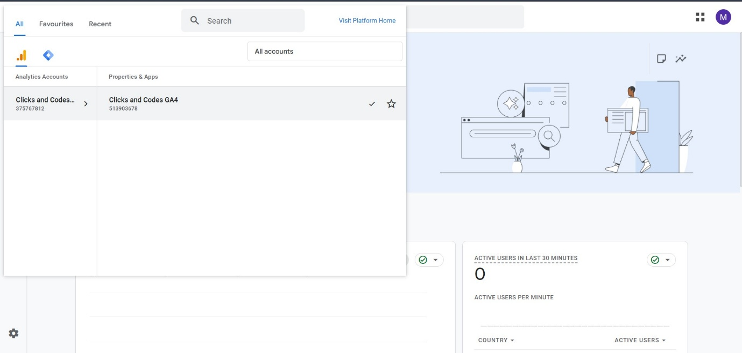

Q-3) Submit the sitemap and robot.txt file in the search console for your website.
Answer- 3
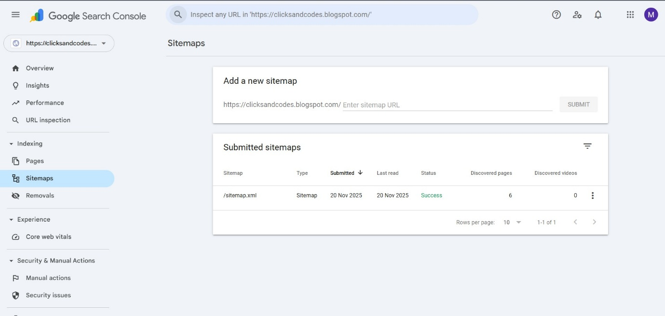
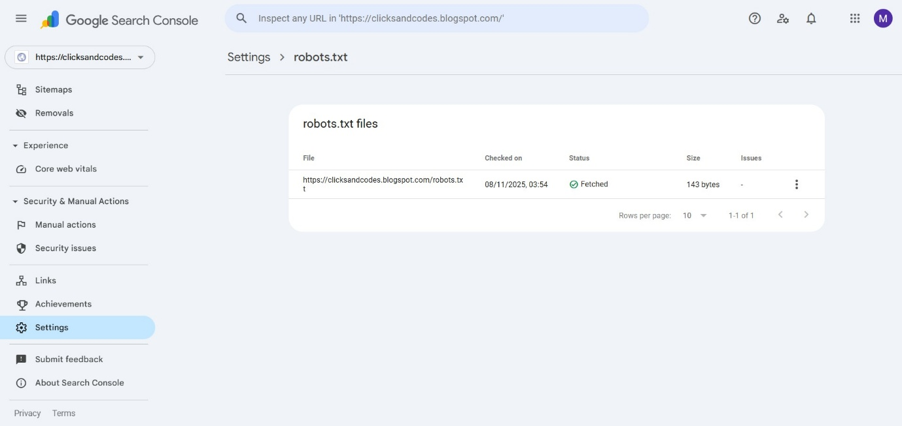
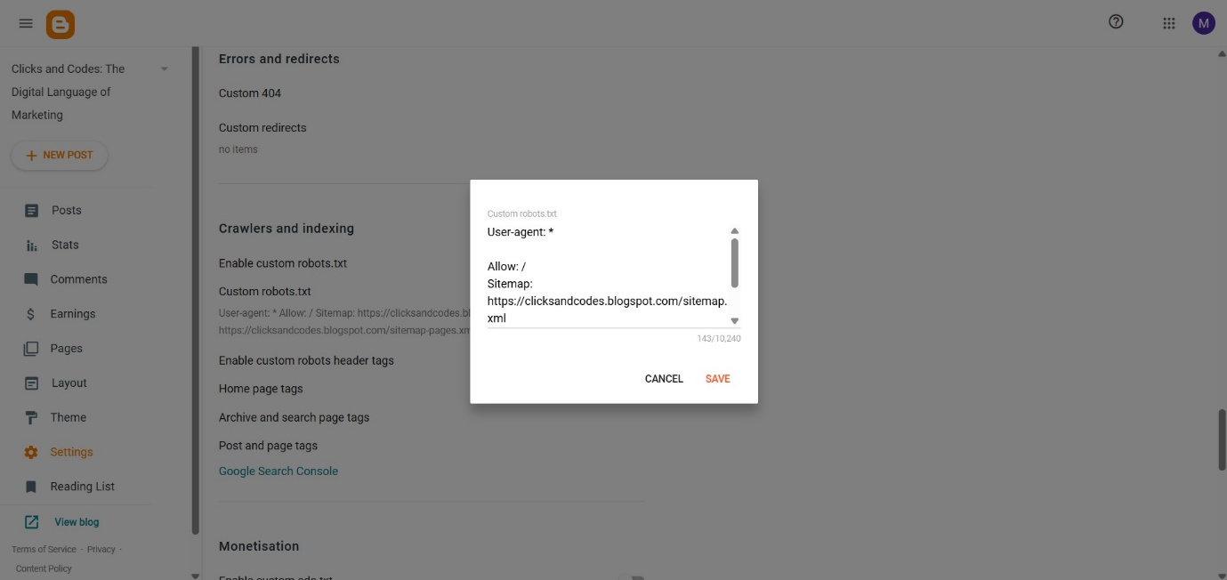

Q-4) Submit the user flow and traffic source reports for your website.
Answer- 4
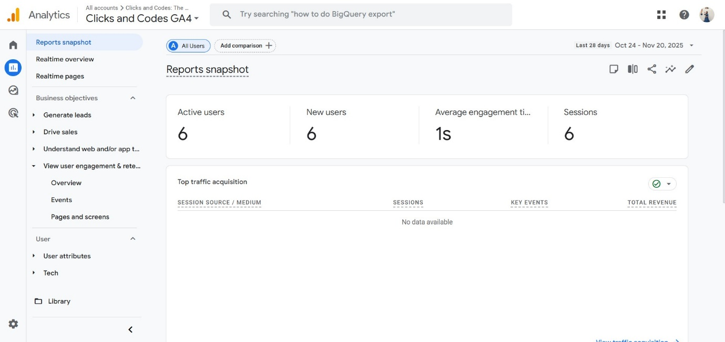
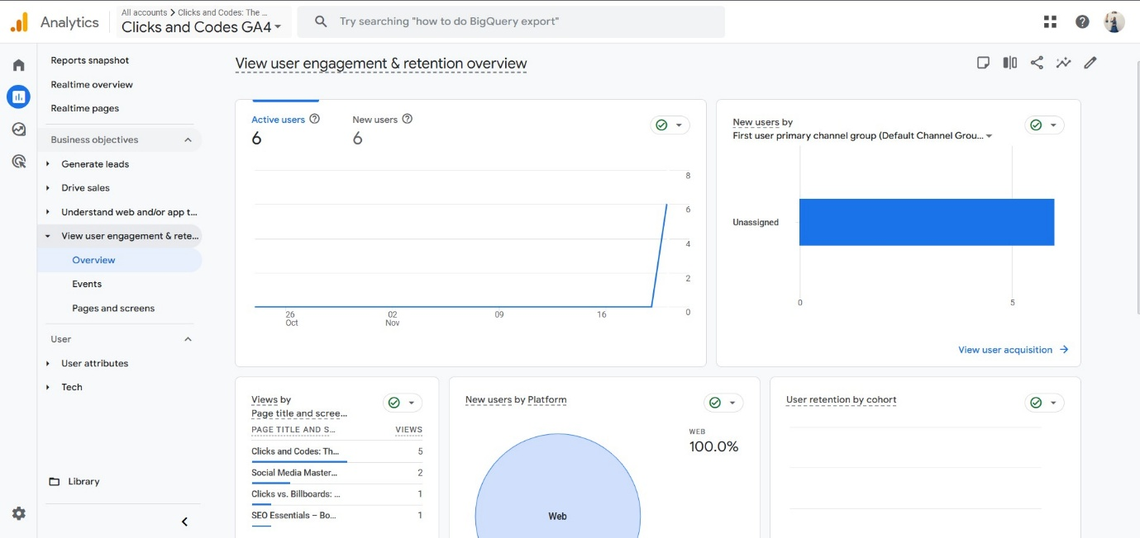

Q-5) Connect your blog to Google Analytics and study the different types of traffic on your site.
Answer- 5
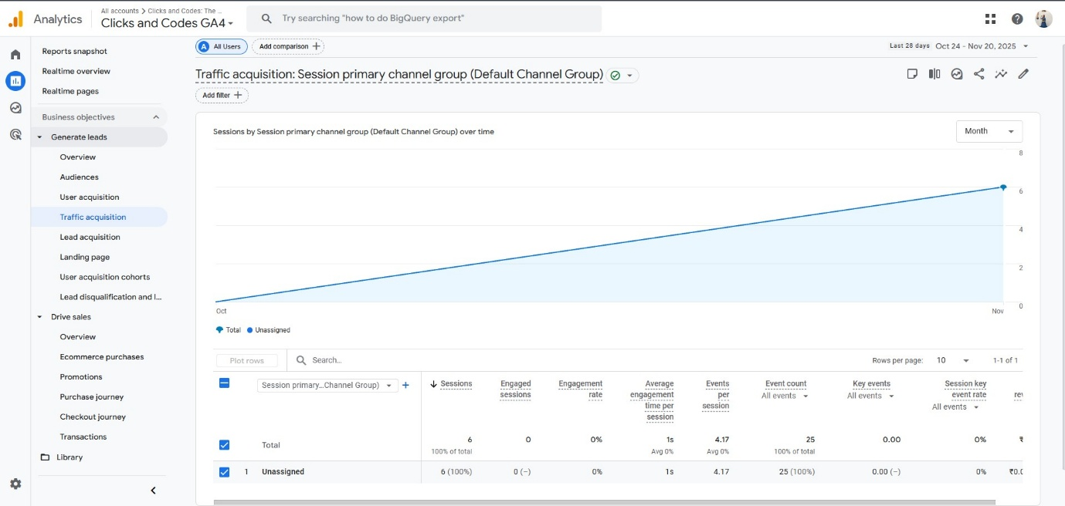
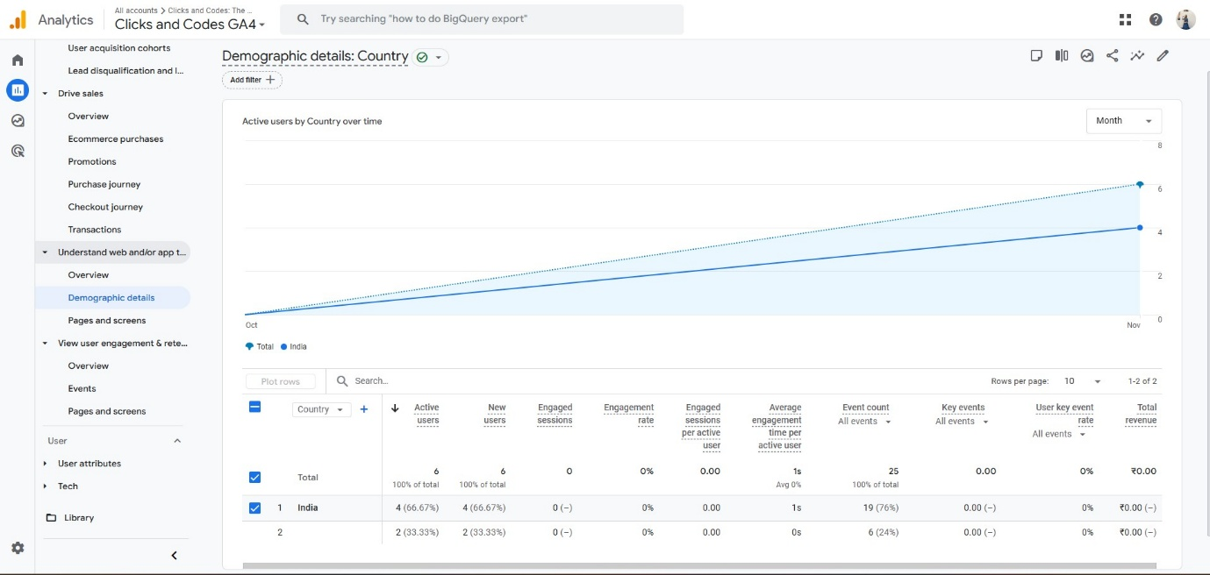
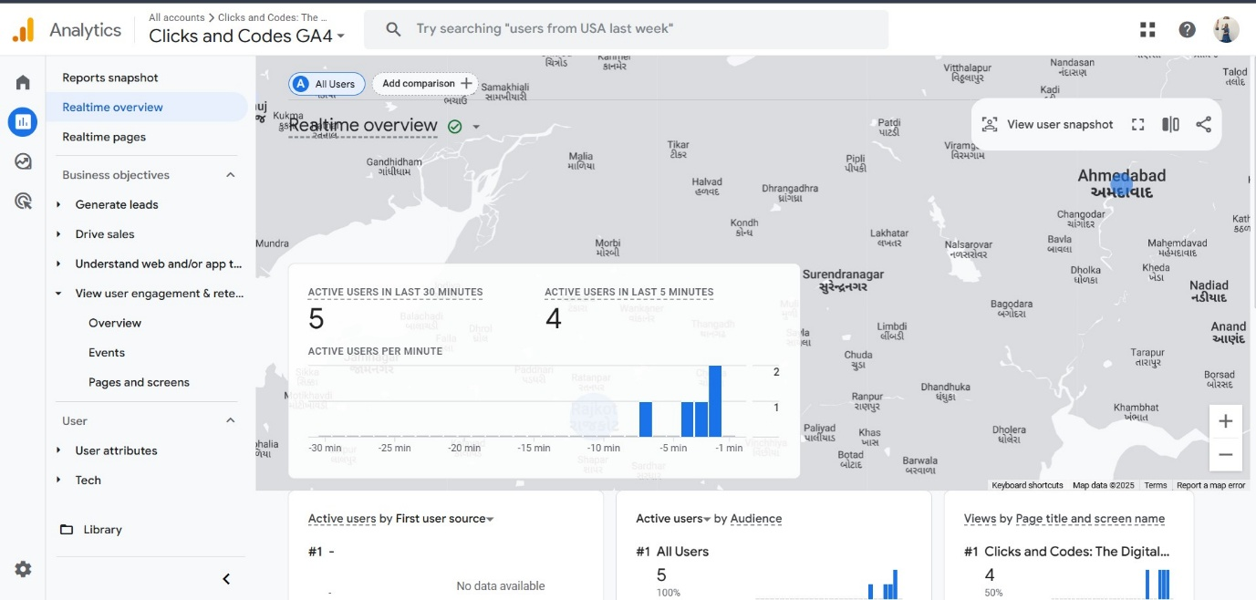
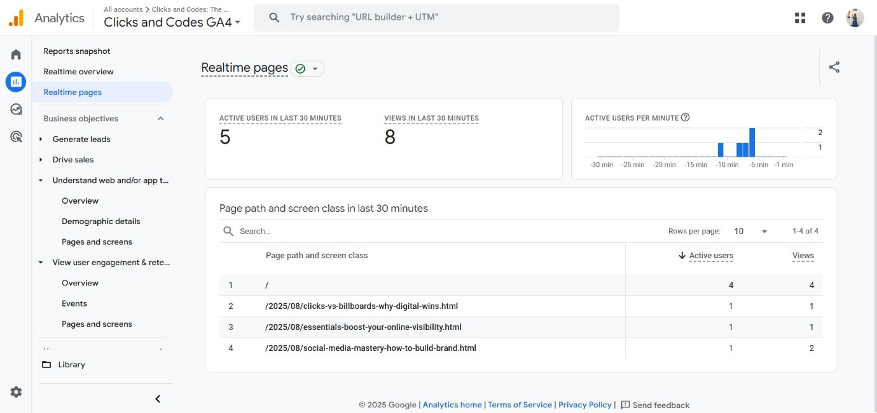

Q-6) Create a goal for your business and study reports whether it has been completed or not.
Answer- 6
In Universal Analytics, these were called Goals.
In GA4, they are now called Conversions.
A conversion/goal is any action that is valuable for the business, such as:
- Contact form submission
- Purchase
- Lead generation
- Button click
- Newsletter signup
- Add to cart

Step 1: Create an Event for Your Goal (Using GTM)
Suppose your business goal is “User should click the Contact Us button.”
You create an event in GTM:
- Trigger condition → When user clicks the Contact button
- Event name → contact_button_click
This event will appear in GA4 → Configure → Events.

Step 2: Mark that event as a Conversion
In GA4:
- Go to Admin → Events
- You will see your event (ex: contact_button_click)
- Turn ON the toggle “Mark as conversion”
Now GA4 will track it as a Goal/Conversion.

Step 3: Check if your goal is completed
Go to:
Reports → Engagement → Conversions
Here you will see:
- How many users completed the goal
- How many times the event fired
- Which page contributed the most
- Which traffic source helped achieve the conversion
- Device-wise breakdown (mobile, desktop)

Interpretation Example (Write this in your assignment)
Let’s assume the goal was:
“At least 20 people should click Contact Us button in 1 week.”
In the Conversions Report, you see:
- Total conversions: 26
- Main traffic source: Organic Search (12)
- Device: Mobile users clicked more (18)
Conclusion:
The business goal was successfully completed because your target was 20 clicks and the actual conversion count is 26.

Why goal tracking is important?
Goal tracking helps businesses:
- Understand if marketing efforts are working
- Identify which channels bring valuable users
- See which pages encourage conversions
- Improve user experience
- Measure performance of campaigns
Without goals, you only know traffic, not success.

Q-7) Track the following interactions in Google tag manager for https://clicksandcodes.blogspot.com/
● Link clicks
● Page load
● Time (How long a visitor stayed on a particular page )
● Button click
Answer- 7
